TERMWORK 1

NAME: Aman Latif

USN: 2GI20CS010

DATE: 21/11/2022

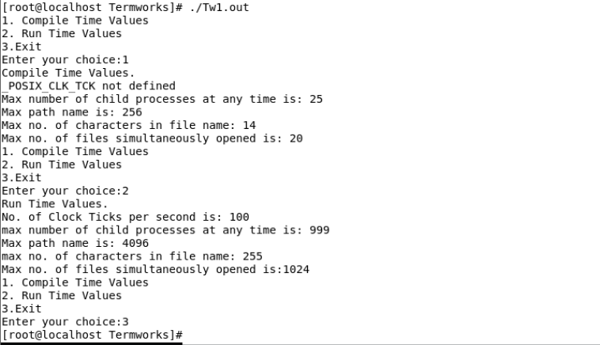

TERMWORK 2

NAME: Aman Latif

USN: 2GI20CS010

DATE: 21/11/2022

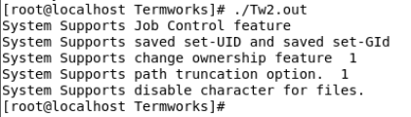

TERMWORK 3

NAME: Aman Latif

USN: 2GI20CS010

DATE: 02/12/2022

When file is locked, another process cannot access that file

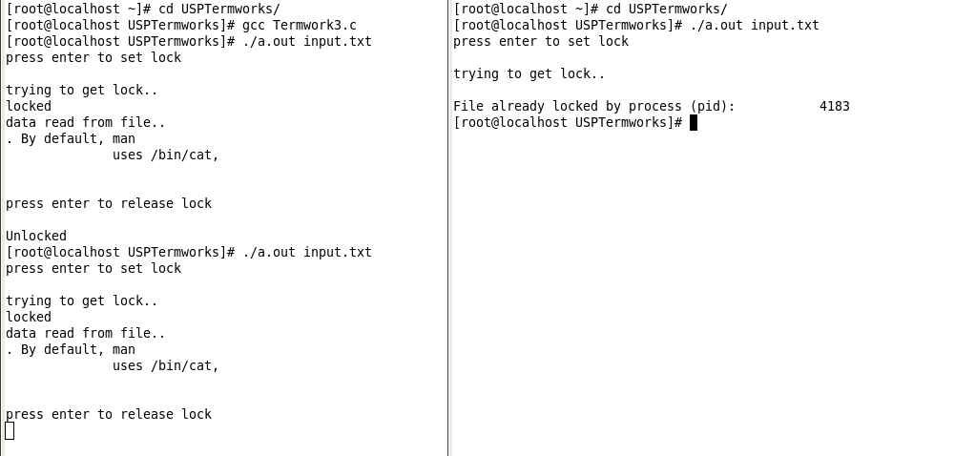

When file is unlocked, another process can access the file

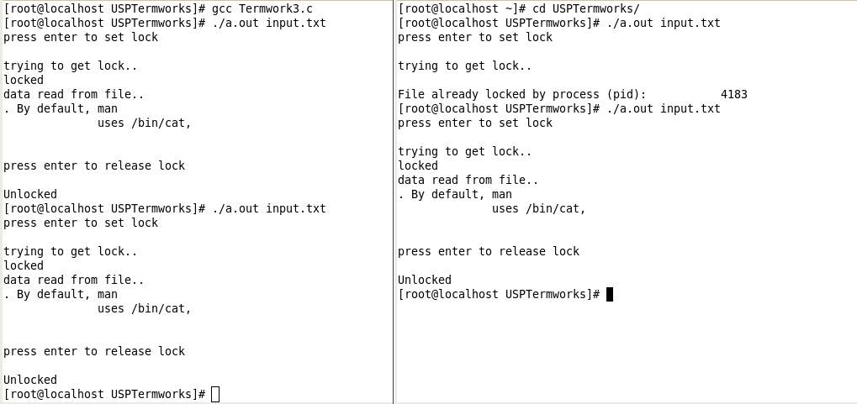

Termwork 4

NAME: Aman Latif

USN: 2GI20CS010

Date: 12/12/2022

**Terminal 1**

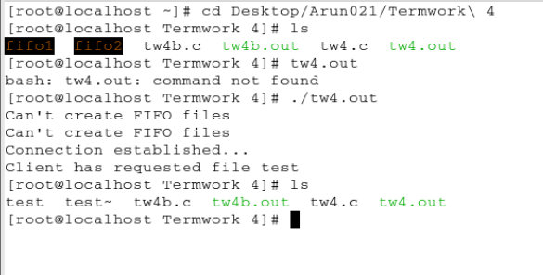

**Terminal 2**

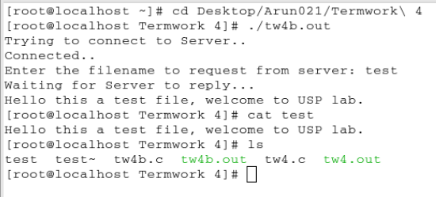

Termwork 5

NAME: Aman Latif

USN: 2GI20CS010

Date: 05/12/2022

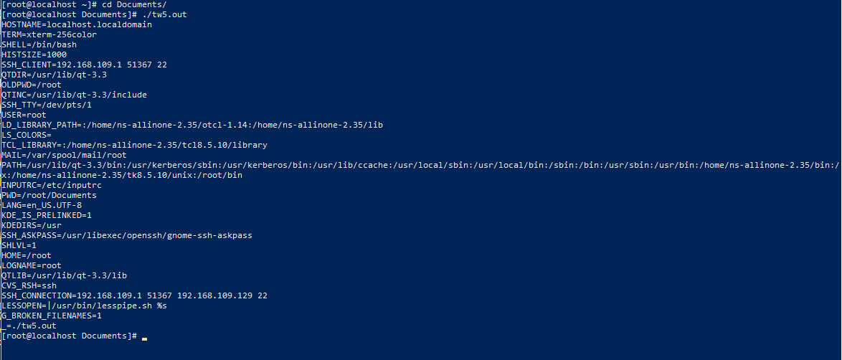

Termwork 5b

NAME: Aman Latif

USN: 2GI20CS010

Date: 05/12/2022

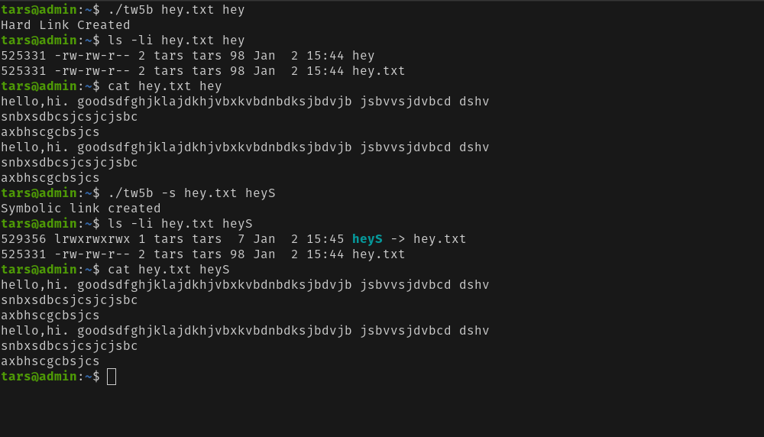

TERMWORK 6

NAME: Aman Latif

USN: 2GI20CS010

DATE: 26/12/2022

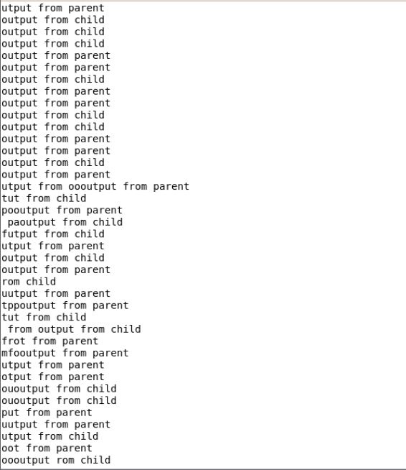

TERMWORK 7

NAME: Aman Latif

USN: 2GI20CS010

DATE: 26/12/2022

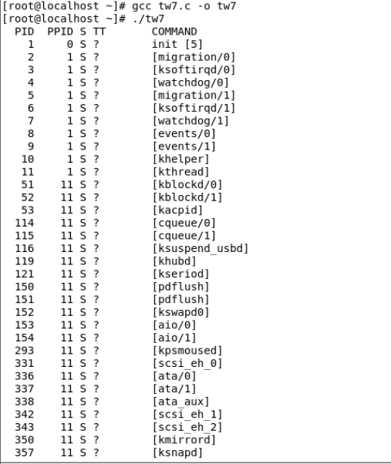

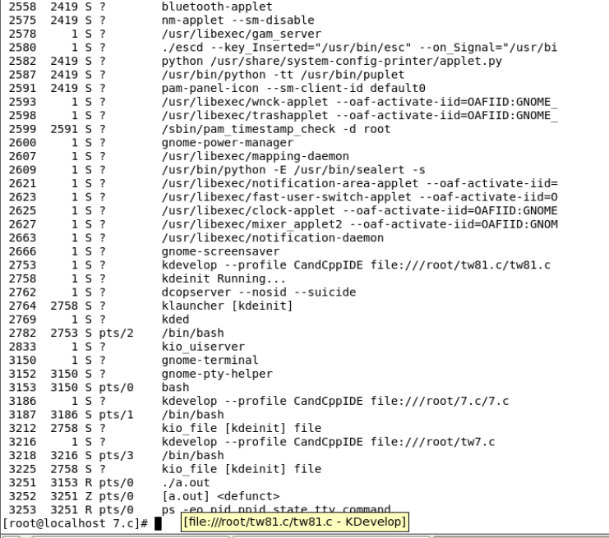

Termwork 8

NAME: Aman Latif

USN: 2GI20CS010

Date : 05/01/2023

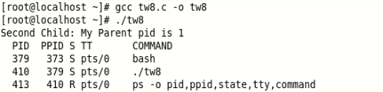

Termwork 9

NAME: Aman Latif

USN: 2GI20CS010

Date : 05/01/2023

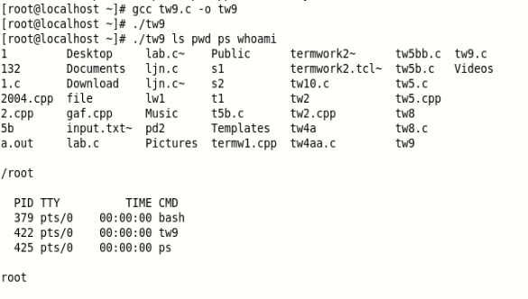

Termwork 10

NAME: Aman Latif

USN: 2GI20CS010

Date : 05/01/2023

